Class 2 Handout

Table of Contents
Review 2
Note for Class 2 Handout...: 4
If Statements 5
Types of If Statements 6
Types of Conditions 7
A Simple Program with Conditions 8
Loops 16
While Loops 16

Review
Last time we output text to the console, received input from the user, and we also talked about class Objects. Whenever you look at something in the physical world, try to think of what would be an Object, its Functionality, and Attributes it may have!

With Syntax, remember that commands end with a semi-colon ; Commands are usually statements that are one-line long.
Functions, If Statements, and Loops will not have a semi-colon at the end.
Classes have a semi-colon at the end of the closing curly-brace.

Curly Braces { } surround a body of code that belong together. This could be a class definition, a function's code, or code to be carried out within an if statement or loop.
int main()  {  // Code goes here  } | class Cat  {  // Object's Functions and  // Attributes definitions go  // here.  };

When we come across square brackets [ ], these are used for array indices. An array is essentially a list of numbers, characters, strings, etc. We will cover them later.

Basic datatypes:
- int – Integers. Whole numbers, positive, negative, and 0.
- float – Floats. 0, Positive & Negative numbers with decimal points.
- char – A single character; it could be any symbol such as numbers, letters, !@#$%, etc.
- string – A string of characters. If you were storing names, it would be in a string.
- bool – Booleans. These will only ever have two values: True or False. Handy for asking the program questions to choose behavior, like “Is Car in Drive?”

Comments:
// Is a single-line comment

/* Lets you do
Multi-line Comments */
Parenthesis ( ) are used to pass variables between functions, and they will also contain conditional statements for if statements and loops. If these conditional statements are true, the if statement or loop will run.

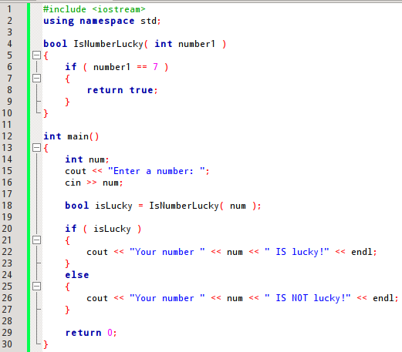

Note for Class 2 Handout...:
As you read through the sample source code in this handout, try to recognize which items are Variables, which items are Objects, and which items are Functions. Here is a list of how you can recognize different things:

Variable
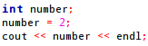

A variable is pretty simple-looking. There are no parenthesis or dots, it is just a name by itself.

Function

You can recognize a function with the parenthesis. The parenthesis may be empty or contain variables, but a function always needs its parenthesis, whether being defined, or being called like in this example.

Class
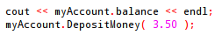

A class can hold variables and it can hold functions.
When you see an instance of a class being used, you will notice a period after its name, and then either a variable name or a function afterwards.

Here, we're outputting the account balance variable, and then we're calling the DepositMoney function and passing in a hard-coded value of $3.50.

If Statements
Changing the way a program runs, based on variable state.

Last class, our programs would run from beginning to end, with no change. We were just inputting and outputting data.
With every-day computer software, there are many variables with different values, and the programs will behave differently based on an event, or a state.

If the user clicks "Save", open up the Save Dialog box

If the user clicks "Send Form", and the "Name" field is blank, open up Error Message

If the user presses the "Left Arrow" key, move the player avatar Left at velocity V

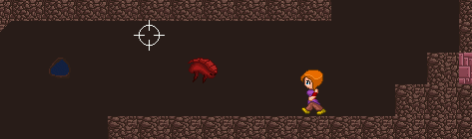

If Player and Bug collide, remove 10 health from Player's HP

And so on.

There could also be multiple outcomes, and a "default" case if none of the things we are looking for are true...:

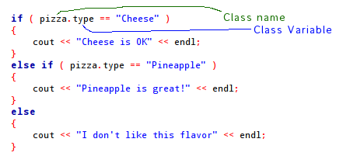

Here, we have an object pizza, which has an attribute type. For this scenario, the type variable is a string.

Types of If Statements

In C++, you can have an if statement by itself:
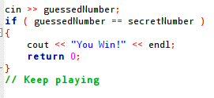

You can consider whether the statement is true or false with an if/else statement:
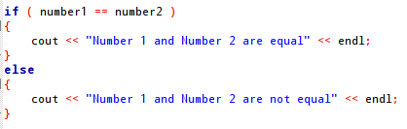

And you can also through an else if in the works.
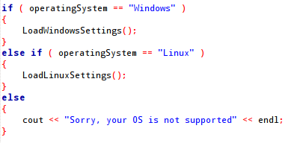

You can have as many else if statements as you want, and you don't need to have an else statement at all if you don't want to handle that state.

Types of Conditions

You can ask different types of questions in C++. Above, we check to see if things are equal to each other, but we can also ask if numbers are greater than or less than, if something is not another thing, or if a boolean statement is true or false.

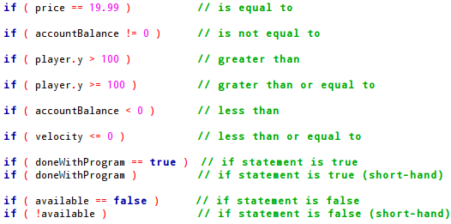

Notice that when we're asking if something is equal to another, we use double-equals = =
However, if we're assigning a value to a variable, we use single-equals =.

Additionally, you can also string conditionals together with "and" and "or".
"and" shows up as &&, and "or" shows up as || (this is two pipes – press shift and \)

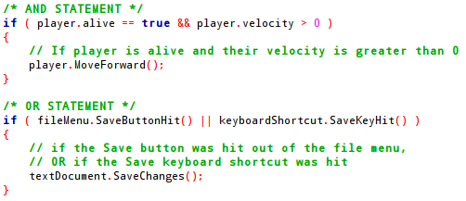

So, now when you're looking at objects around the room and their functionality, try to also take into consideration how it might act different, if one thing is true, or another thing is.
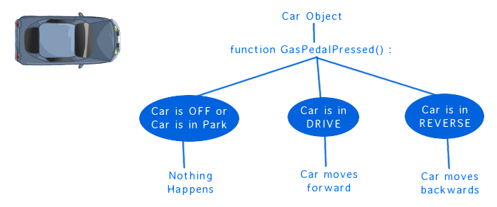

How about a TV Remote? What functionality does it have, and how does it behave based on the state of the Television?

A Simple Program with Conditions
So, let's create a "Virtual Car" program.
With our virtual car, we can start the car, change gears, and hit the gas. The logic of how it behaves is outlined in the tree above.

So, let's create a new project by going to
File > New > Project...
And then create new files with
File > New > Empty File

We will want to create main.cpp, Car.h, and Car.cpp.

We will start by adding the bare-basics of what we need in main:
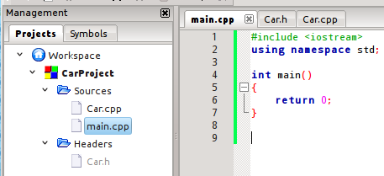

Again, main() is where the program starts from, so we always need to define this in some file. Our file doesn't need to be main.cpp, it could be class2.cpp or anything else you want, but we need
int main() defined in the program.

In Car.h, we will create our class prototype. In C++, it is standard for a class to have its own source files. The prototype (or declaration) goes in the header .h file, and the definition goes in the source .cpp file.
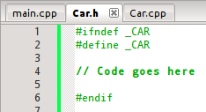

In our header file, we need to start by adding:
#ifndef _CAR
#define _CAR
#endif

These are preprocessor commands, that essentially tell the compiler if you've read this file already, skip it. If we didn't have these commands, and we were including the Car file in multiple source files (which is not uncommon), it would read this file multiple times, and think we were declaring our Car class over and over!
Literally, these preprocessors are saying "if _CAR is not defined (ifndef), define _CAR". Therefore, if _CAR has been defined, it won't go over the code a second time.
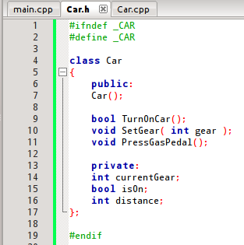 | When we create our class, we will have private variables like currentGear, isOn, and distance.  These variables are hidden from the user, and only the car needs to know.  Then we have our public members. This is what the driver will interface with.  The driver will be able to TurnOnCar, SetGear, and PressGasPedal.  Finally, there is Car(); defined on line 7. This is a Constructor, and you can think of it like a function that executes immediately after we create a new car.

Next, lets open the Car.cpp file:

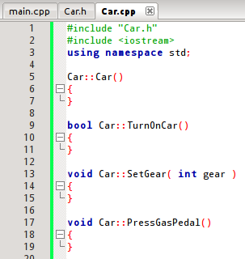 | We don't need the #ifndef preprocessor commands here, since this is a source file. This is where we set what all the functions actually do.  On lines 1 and 2, we're including Car.h, and iostream. We need to include the corresponding .h file for this .cpp file.  Then, we have all of the functions from Car.h listed, but with curly-braces to hold our function bodies.  Notice that on line 5, the Constructor Car() has no return-type. Constructors are meant for initializing variables, and do not return data.

Also notice that each of the function names are prefixed with Car::. When we write functions outside of the class itself, we need to specify which class it belongs to. We do this with the Car:: prefix.
However, if we call one of these functions (ie, from main) we do not need that prefix.
So in our class, we have three variables. Lets initialize what they are:
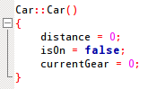 | With distance, we're going to keep track of how far forward and backward the car goes. We're starting it out at point "0".  We're starting the car off, by setting the isOn boolean variable to false.  And we're setting the current gear to 0. We can say that 0 is the code for being "In Park".

Then, we can define what happens when
the user tries to turn on the car:
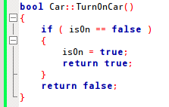 | Here, we are first asking, "Is the car off?" by saying:  If the variable isOn is false...  If the car is currently off, we turn it on by setting  isOn = true;  and then we return true; because the car turned on successfully.

When we return a value inside of a function, nothing else in that function is executed. Once we return true from within the if statement, it will never reach the return false statement.
What we have above is essentially an "if/else", but it would be redundant to have an "else" in this case, since if teh car is on then there's nothing else TO return but false!

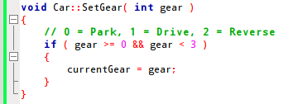 | For SetGear, we are allowing the user to pass in a value for "Gear".  We are only going to accept 0, 1, and 2 as valid gears for the car to be in, so we need to check that what was passed in was valid, first.

With our if statement, we are asking,
Is the gear between 0 and 3?
by asking
If the gear is greater-than-or-equal-to 0, AND
if the gear is also less than 3
If the gear is a valid number, we change our currentGear. Otherwise, we ignore the command.

And when we're handling the gas pedal being pressed, we have to consider the state of the car --
Is the car on? Is it in drive? And so on.
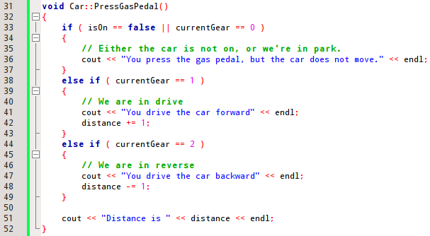
On the first if statement, we check to see if the car is off, OR if the car is in Park. If one or both of these are true, then nothing happens and we output a message about the car not moving.
Because this first if handles the case of the car being off, for the subsequent else if statements, it is not possible for the car to be off and handled by these.

If the car is in drive, then we will output that the user has moved forward, and we will add 1 to the distance.
We can increment the distance in different ways:
distance = distance + 1;
distance += 1;
distance++;
++distance;

Each of those commands will allow us to add one to the distance. The top two will let us increment by some number other than 1, as well.

If the car is in reverse, we merely subtract the distance.

And, finally, whether the car stays in the same place or moves, we are going to output the current distance.

So we have defined what a Car is, and how it behaves. We have created the object, its attributes, and its functionality.
Now that we have a Car, we need some way to interface with it.
Let's go back to main.cpp, and add a Car.:
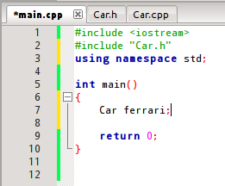 | We have added the include on line 2, and a new Car on line 7.  We do not need to include the .cpp file, only the .h file.  To have the user interface with the car, we will want to get input from the user.  Additionally, we don't want the program to quit after just one runthrough, we'd like to see the distance get larger or smaller as the player drives!

Well, let's throw in a loop, even though we haven't covered what they are yet. We will essentially be adding a condition:
While the player still wants to play, run the program again!
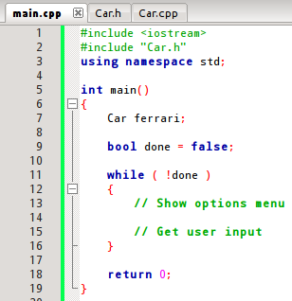

So, we're creating a bool value to store whether we're done with the program. Then, while the program is still running, we will do things like show the user a menu each time, and then get their input.
Our menu might look something like:
Choose a command:
- Turn on car
- Change gear
- Press gas pedal
- Quit program

And only when the user selects option 4, will we change done to true.
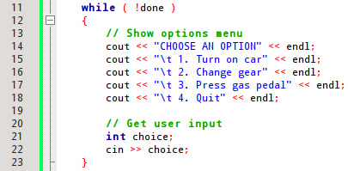 | Inside the while loop, output menu options and then get the user's input.

Once we get the user's choice, we will have another if statement to figure out what to do:

while ( !done )
{
// Show options menu
cout << "CHOOSE AN OPTION" << endl;
cout << "\t 1. Turn on car" << endl;
cout << "\t 2. Change gear" << endl;
cout << "\t 3. Press gas pedal" << endl;
cout << "\t 4. Quit" << endl;

// Get user input
int choice;
cin >> choice;

if ( choice == 1 )
{
ferrari.TurnOnCar();
}

else if ( choice == 2 )
{
cout << "What gear? ";
cin >> choice;
ferrari.SetGear( choice );
}
else if ( choice == 3 )
{
ferrari.PressGasPedal();
}
else if ( choice == 4 )
{
done = true;
}
else
{
cout << "Invaild command!" << endl;
}
}

Notice that we even have an "else", for when the user inputs something besides options 1 – 4. It will just let them know the command was invalid, and then the loop will repeat to get their next command.
So now if we run the "game", we will get something like:
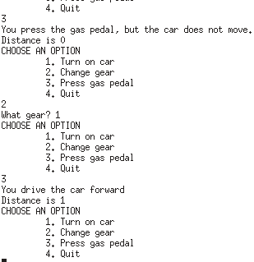 | If you want the entire sample code for this, go to the "Samples" folder under "Class 02" on the class website.  Not the prettiest thing ever, and could use some cleaning up, but I'll leave that to you to figure out. :)

Loops
I know you're feeling disappointed that I used a while loop in our Car program. It's almost like I spoiled what your Christmas present was going to be. I'm sorry. But don't worry, there are more to loops than just that!

While Loops
While loops look really similar to if statements:
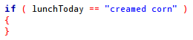 | 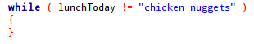

They both have a conditional statement within parenthesis ( ... ), and then have a body following, for code to run if that conditional statement is true.
The difference, however, is that the loop will run multiple times, up until the conditional statement becomes false. Because of this, it is easy to get trapped in an infinite loop:
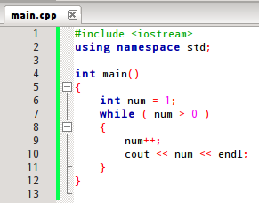 | 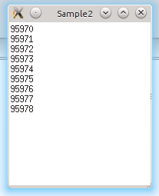  Are we there yet?

The program relies on the fact that something inside the while loop really ought to make the while's conditional statement false.

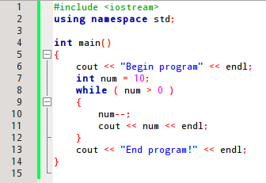 | 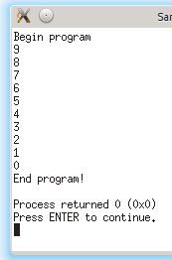

While loops could be useful for:
- Continuing a game until the user hits quit
- Running through a list of items and processing them
- Looping until the user finally enters a valid option

And other things.

We'll go over this more next class. This was just a brief introduction to loops!

